# Project Overview

## Client Background

The client is Ezible Klanders. She is the CEO of SRI (Schizophrenia Research Initiative), a company that is a not for profit charity that specialises in funding mental illness research, specifically the mental illness schizophrenia. She wants to create this website and charity as she has experienced a Schizophrenic way of life and wants to help as many people as possible. She has access to a graphic designer in order to advertise and create graphics, as well as knowledge of who and why people will be coming to the charities website. She however needs a website for the business to grow and allow ease of access within the world. This website will be used to allow people to get help, as well as explain objectives of the company and allow people to donate in order to fund research into Schizophrenia.

## Goals

We had asked Ezible questions regarding what she wants for each page and what her main goals were, for example “What do you want on the donation page of the website?” etc. From these questions we have created the following main ideas wanted in the website.

The goals that Ezible wants on the website includes a page dedicated to where the money given to the charity goes, what companies are helped, and a transparent explanation of why the money goes where it goes. Ezible wants this in the form of a counter on the front page of how much money in total is given, as well as on the donation page with a rounded edge vertical bar showing percentages of where the money goes, the explanations are wanted to be attached to this bar using thin lines. She also wants the donation button on this page, as well as the header and navigation bar.

Ezible was very specific that she wants a page dedicated to self-help for the visitors as she knows that most of the pages visitors will be people looking for help. This page should link to other websites that describe Schizophrenia, and show ways to help. She has specified the Headspace website to be included ("Headspace National Youth Mental Health Foundation" 2018).

Ezible also wants the whole page to be simple and minimal, with easy navigation to each page. At the bottom of the page she wants logos regarding the companies the charity supports. She wants the colour scheme to be light blue and white. She says she likes the style of SANE Australia ("SANE Australia" 2018)

## Scope

The website that will be created will have a page dedicated to where the money for the charity goes, and all the companies that the Not for Profit helps (We will use placeholder images for the company logos). There will be a main page with the company’s main goal (To help research into the illness schizophrenia) linking to where the viewer of the page can donate along with links to where the money goes. There will also be an “About Us” page discussing Ezible and who she is, what she is doing and why.

Ezible also mentioned how she wanted to have on the site links to various self-help websites for people visiting with the illness, as most of the visitors will be looking for answers for their ailment.

As the company is a not for profit there will need to be a donation button both on the main donate page as well as the navbar, this will link to the donations information (The page which transparently shows where the money goes).

## Target Audience

The target audience are people who will be either inflicted with mental illnesses, and people willing to give their money to support research. They will be aged 15 to 70 (Although any person of any age may go on the site), so the website will need to be clean and simple, easy to navigate. The gender of the visitors will be both male and female. They will be using Windows and Mac operating systems (small amount likely to be using a Linux operating system). Screen resolution will most likely be 720p or 1080p for users using Windows, and up to 2880p for Mac. The visitors will most likely be using Edge or Chrome on Windows, and Safari on Mac. Users will also more likely be using phones so the website will need to have a mobile first approach (This has been explained to Ezible and she agrees with this). Mobile phones used will be Android and iPhones, most likely using the safari and Chrome phone web browser.

## Requirements

### Business requirements

Complete transparency with the user, this will be achieved by an accurate representation of where the money given to the business goes. This will be needed to keep the reputation of the business high and have an overall transparency which Ezible believes will have a positive impact on the charity.

### User requirements

Users need to be able to understand the general layout of the site. They also will require to have links to self-help pages and simple ways to cope with their illness, as Ezible believes most of the visitors will be afflicted. The point of this money is to allow people to donate in order to support research into Schizophrenia, so the website should be designed in such a way that makes users more likely to donate.

### Functional requirements

The website as a whole needs to be simple to aid ease of access and use, it also needs to have a navigation bar that is simple and clean and shows the user what page they are on. The donation button needs to also be clean and allow people to pay and support. There will need to be CSS 3, HTML 5 in order to create a functional site which is mobile first. The site will need to be responsive.

# Site Design

## Home

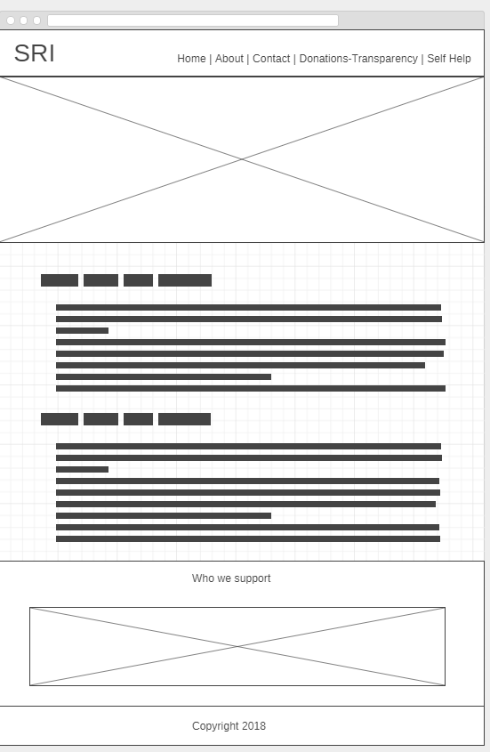

## About Page

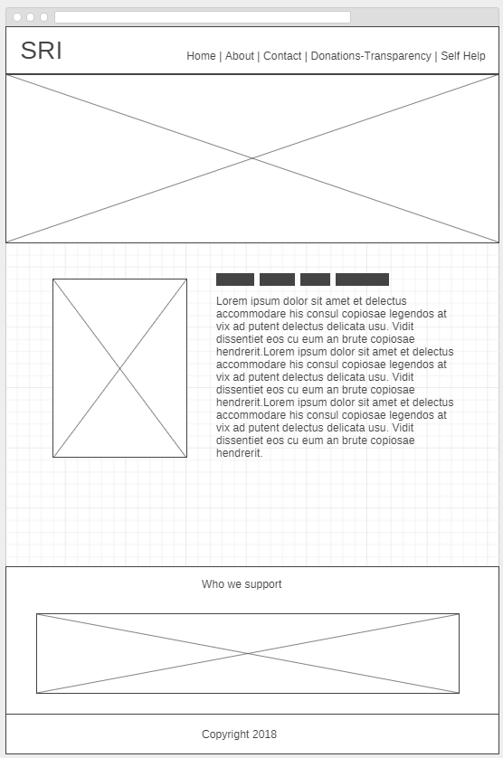

## Contact

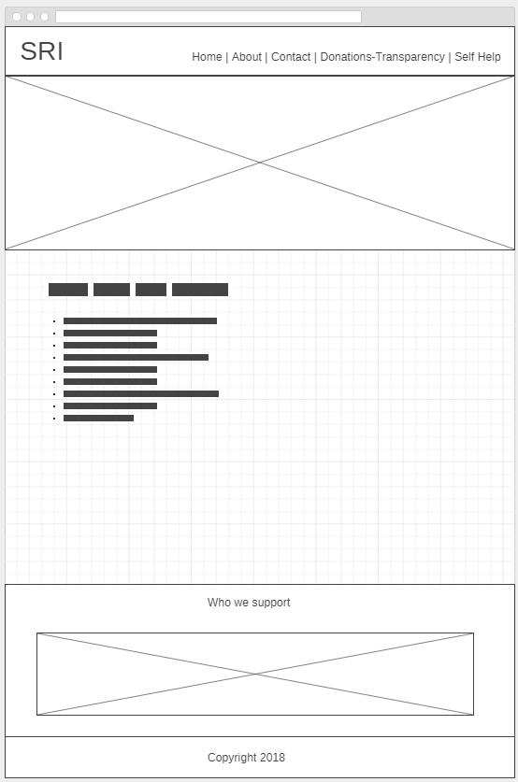

## Donations

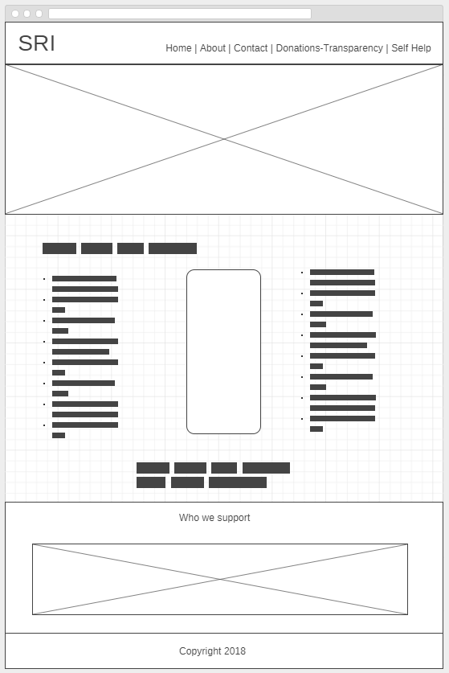

Self Help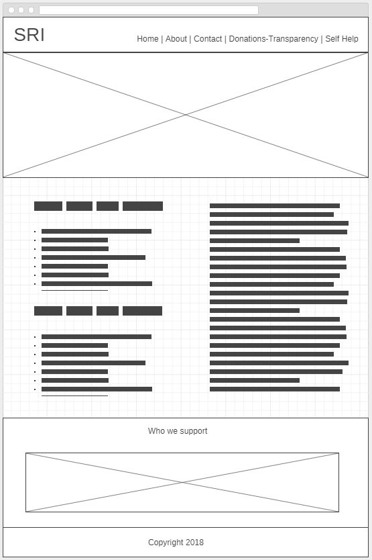

# Hierarchy Chart

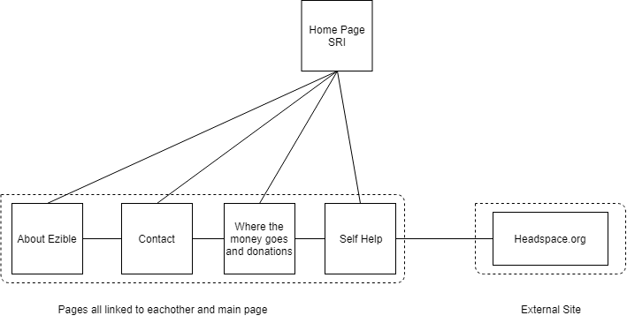

Headspace.org.au

# References

"Headspace National Youth Mental Health Foundation". 2018. Headspace.Org.Au. Accessed April 5. https://www.headspace.org.au/.

"SANE Australia". 2018. Sane.Org. Accessed April 5. https://www.sane.org/.